**Due date**: Wednesday, October **5th**, 2016

**Purpose**: Demonstrate successfully installing and updating the **Ubuntu Desktop 16.04** as a virtual machine with VMware.

**Marks:** 10

**Procedure:** The following instructions will guide you through the installation process for VMware **Workstations 12.** We will use this software throughout CST8101 to run Linux and Windows operating systems.

Go to <http://www.ubuntu.com/download/desktop> and download Ubuntu 16.04 to a directory on your local hard drive.

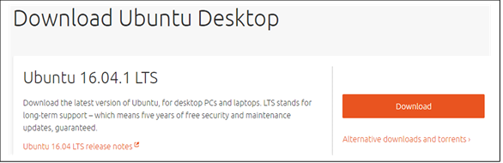

1-Instruction for Acquiring and installing VMware workstation 12

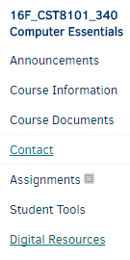

Login to your **BB** and choose Computer Essentials 8101 340

and click on **Digital Resources**



Login to **Algonquin College** with your user id and password



Click on Continue to **Digital Resource Portal**

Click on **Your Software** tab and choose **VMware**

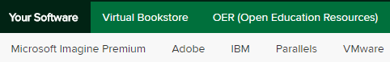

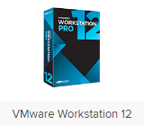

Select **workstation 12** for Windows and click on **Express checkout**

Note: for Mac machine choose **VMware fusion 8**

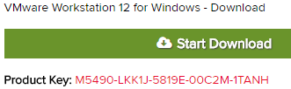

The next screen presents you with VM product key.

Make sure to save this **CD-Key number**. You need it for later.

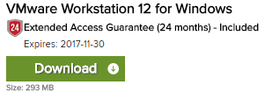

Click on **Start Download** to download the file (**293 MB**)

**2-Installing Workstation 12 (VMware )**

Locate the downloaded file and launch the application.

(Usually, it is in the download folder) VMware will load

and the installation wizard will start. Click next

Choose **Typical** click **Next**



Select the fold to install and click **Next**

Select what shortcuts you want and click **Next** .





On the **Ready to perform requested operation** page click **Continue**

As packages are installed, the status bar will indicate their progress.



Wait for all tolls to be installed and don’t be impatient if the status

bar doesn’t change for a minute or two



Enter the license key found on the order sheet you saved. Press

**Enter** when you’ve done this

**3-Creating a Virtual Machine (installing Ubuntu)**

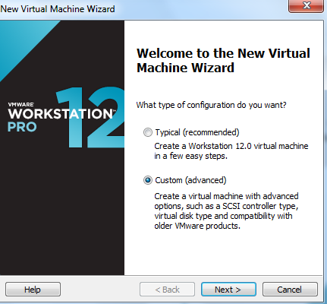

Start VMware Workstation (shortcut on your desktop)

Select **File**🡪**New Virtual Machine**, choose **Custom,** click **Next**

Click **Next**

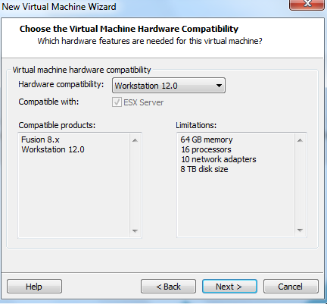

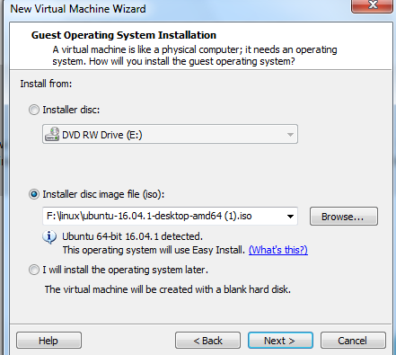

in the **Guess operating installation** page

Choose **installer disc image files (ISO)** radio button

And then click on the **Browse** tab to find your Ubuntu file



You should see this path

Then select **I will install the operating system later radio button** (the same page)

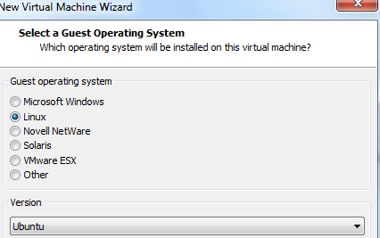

Select **Ubuntu** click **Next**

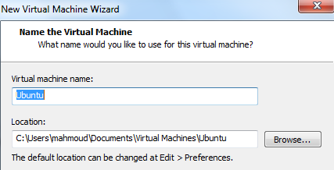

Name the virtual machine **(Ubuntu 16)**

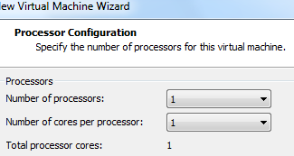

**Process configuration** page, keep the default valueclick **next**

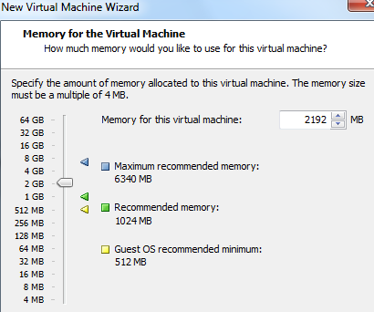

Specify **2 GB** or more of memory click **Next**

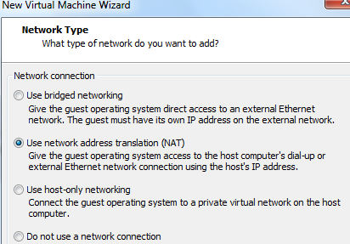

Network type; keep the default value Use **Network address**

**Translation (NAT)** and click Next

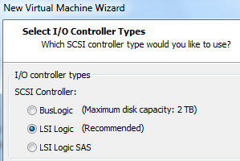

**Select I/O Controller types**. Keep the default settings.

Click **Next**

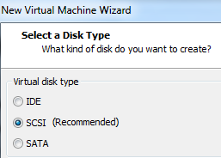

**Select a Disk Type**. Keep the default setting .Click **Next**

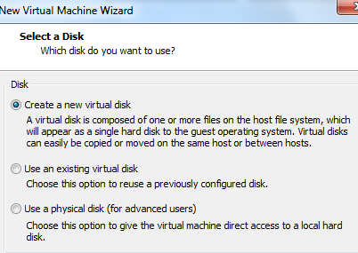

**Select a Disk** (default)

**Create a New virtual disk**



**Specify Disk Capacity** set **the Maximum disk size (GB**): Field to **30**

**GB**. Keep the default **Store virtual disk as a single file** option. Click

**Next**



**Specify Disk File**. Keep the default settings. (i.e. Ubuntu.vmdk)

click **Next**



**Ready to Create Virtual Machine**, Verify the information in the

table is correct and if so click **Finish**. Otherwise, click the **Back**

button and make corrections.

The **summary** page for the Ubuntu virtual machine is now visible

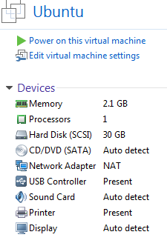

**4-Mount (installing ) the Ubuntu image file**

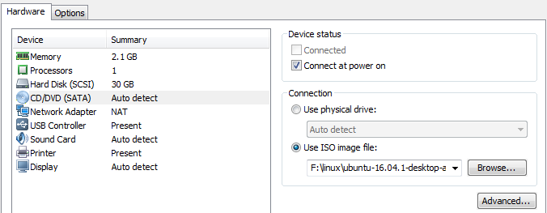

Mount the ISO image to the Ubuntu virtual machine,

From the **Summary p**age, double click on the

**CD?DVD (SATA**) device . This brings up the virtual

Settings dialog

In the Virtual Machine setting dialog box under

**Connection**, select the **Use ISO** image files radio

Button and browse to the location of the Ubuntu ISO file. Click **OK**

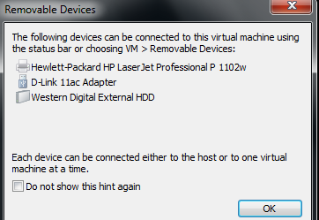

Now Ubuntu takes you back to the **Summary** page

again. Click **On power on this virtual machine** to

turn on the virtual machine.

Note: If you see this page just click **ok**

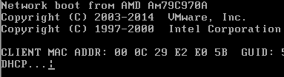

Note: if you got a black screen with a slash is spinning,

That means virtual machine did not find the Ubuntu file .

In your VM machine on the menu bar (blue color)click

On the **VM** tab and choose Power and click on **Power off**

And shut off your virtual machine**.**

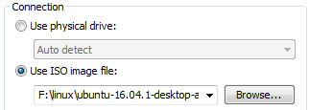

Go back to the **summary** page and under **connection** select

**Use ISO image** file again click on browse and locate your

Ubuntu ISO image files and click **ok**

**5-Installing the Ubuntu into the Virtual machine**



In the **Ubuntu** tab, go to the **Commands** section and

click on **Power on this virtual machine**. If a pop-up window

emerges about the "keyboard hook timeout", click **OK**

in the **Welcome** page click on the **Install Ubuntu** tab

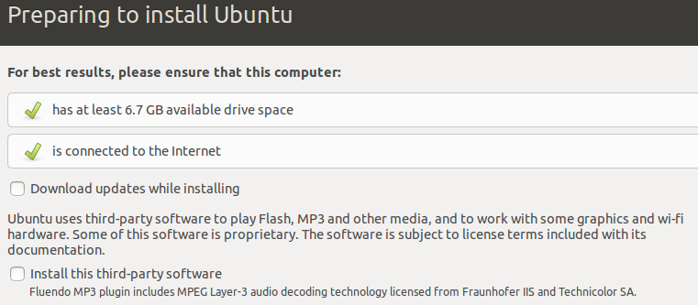

In the Preparing to install Ubuntu page just click Continue



**Installation type,** choose **something else,** click **Continue**



In the installation, type click on **New partition table**

You will get this message, click **Continue**



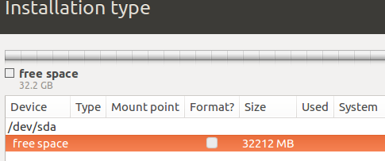

In the **installation Type** unde**r free space (orange)**

Click on the **plus + sign**

Create partition choose these settings:

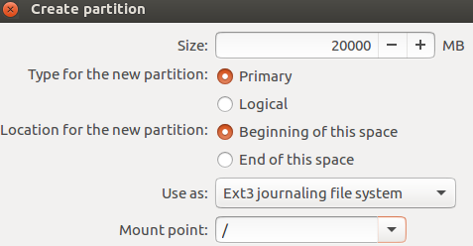

Size: **20000** MB

Type for the new partition: **Primary**

Location for the new partition: **Beginning of the space**

Use as **: Ext3journalling file system**

Mount point**: /**

Click OK

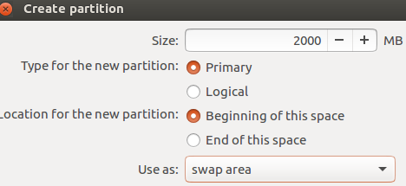

Highlight the **free space** again and click on the Plus **+** sign

To create a **swap area** partition

Size: **2000** MB

Type for the new partition: **Primary**

Location for the new partition: **Beginning of the this space**

Use as: **swap area**

Click **OK**

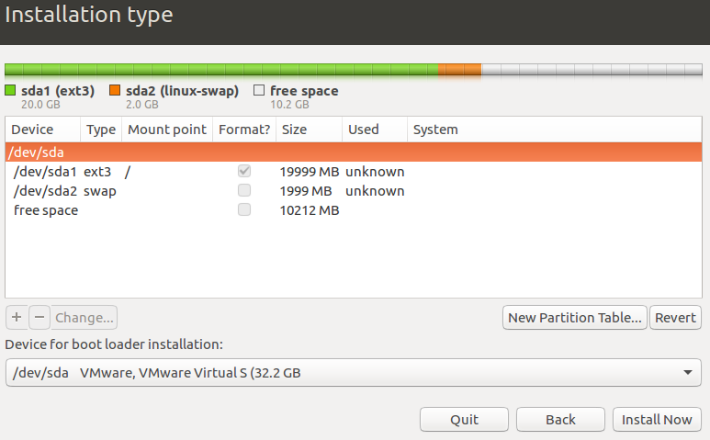

Click on **Install Now**

warning: **write the change disk?**

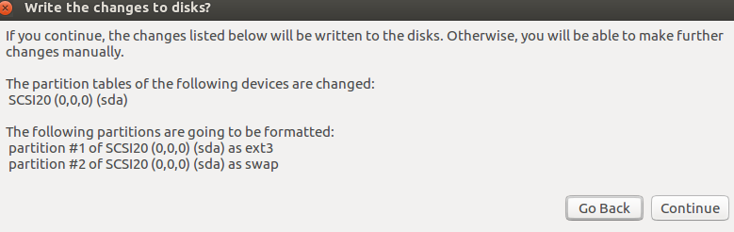

Click **Continue**



In **Where are you**? Type: **Ottawa** and click **continue**

Keyboard layout **English**, click **Continue**

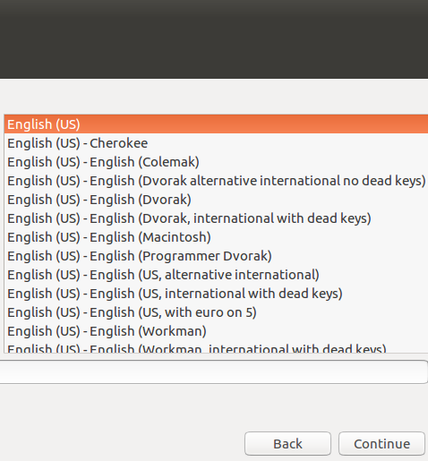

Click and drag

**Important note:** If you don’t see the **Continue** tab

Move your mouse on top of the screen (the black area)

and move the page to the left. You should be able to

see the Continue tab now.



**Setup the username**

Provide a username and password

Go to the default settings

Click **Continue**

**Welcome to Ubuntu** screen begins to install the **Ubuntu** files

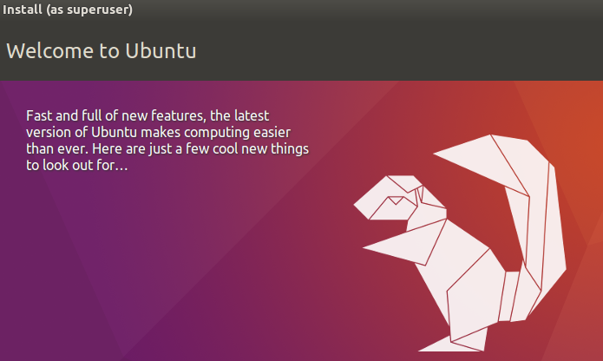

**Note:** this part takes a few minutes

Once Ubuntu is finished, it would ask you to restart your machine

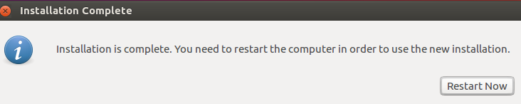

Just click on **Restart now**

You are done**. Press Enter**

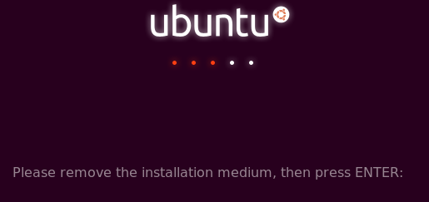



**Note**: When the new operating system boots, you **may/may not**

see errors such as these. If so, click **I Finished Installing**

on the bottom of the **Ubuntu** tab in VMware Workstation.

Click on the error screen and press **1** to reboot, or **power off/on** the

Ubuntu again, Be patient……



Ubuntu should boot normally. When the Ubuntu boot screen

Appears, click on the account you have created and log in as that user.

**Important note**: if you are missing your mouse inside of your computer

(Virtual machine) just press Ctrl+Alt

**Update Ubuntu Linux**



Click on the **Dash** and type update

Then choose **A Applications**

Update page would come up and asks you to confirm and asks you

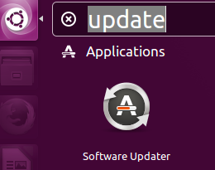

Again for the **authentication**

Provide the **password**

